According to JDBC , we have two types of SQL queries.

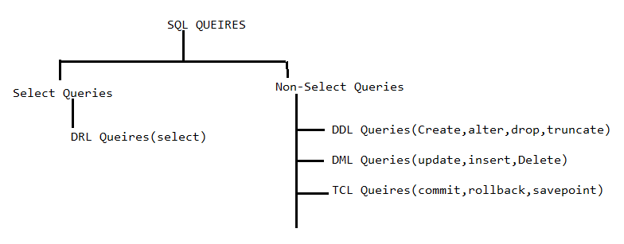

The DML queries that are gone to db s/w from sqlprompt/sql plus will execute in DB s/w by disabling the auto commit mode in DB s/w. Therefore we need to commit non-select sql query execution result separately.

The DML queries that are gone to DB s/w from Java application will execute in DB s/w by enabling the auto commit mode in DB s/w.

**2. SQL Query Execution Phases:-**

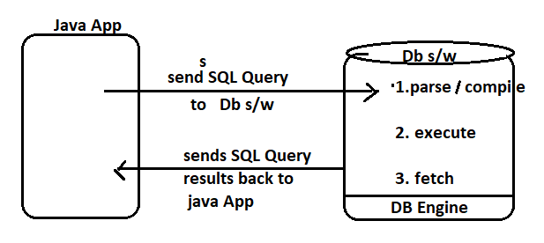

**2.1.parse/compile:-** The SQL query is splitted into tokens and syntax of sql query is verified.



**2.2 . Execute Operation:-** Here parsed query is executed and output will be generated.

**2.3. Fetch:-**  The SQL query result will be fetched out and will be sent to client App(Java app).

**3. Queries Types Based on Inputs:-**  The sql queries have been divided into two types:

a. static queries:- The query with hard coded inputs and without inputs is called static query.

EX:- 1. Select * from student;

2. select * from student where sid=7;

3. insert into student values(7,’suku’);

b. Dynamic Queries :- The query with params(place holder) is called dynamic query.

Ex:- 1. Select * from student where sid=?;

2. insert into student values(?,?);